**Lecture 1**

**Antennas**

Annotation:

In lecture 1 in paragraph 1, basic information about antennas is presented, such concepts as: antenna, dipole moment, radiation pattern are introduced. In paragraph 2, the types of antennas are presented, the definition of the simplest antenna (Hertz Vibrator) is given. In paragraph 3, an antenna array of transverse radiation to the antenna plane is presented. Clause 4 sets out the main characteristics of antennas used in practice.

 Antenna is a device for emitting and receiving radio waves. Electromagnetic oscillations enter the antenna through the feeder (wires, contacts). Oscillations are converted into waves, the length (λ) of which is comparable with the characteristic dimensions of the antenna. We will explain the physics of the process using the example of a Hertz vibrator (an electric dipole, the moment of which varies with time). The dipole moment is called the vector

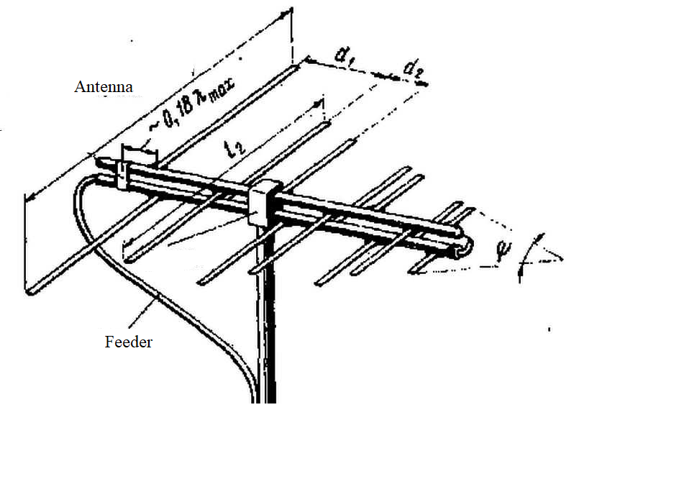

*,*  (1)

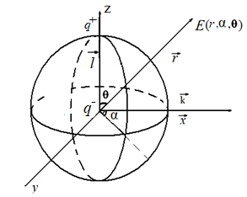

where $\vec{l}$ − is the distance vector from negative to positive charge, $q$ − is the absolute value of the charges. The electromagnetic wave is transverse: the directions of the vectors of the electric field ($\vec{E}$), magnetic field ($\vec{H}$), and the propagation direction of the wave vector ($\vec{k}$) are perpendicular. At any point in space, the value of $\vec{E}$ can be specified through the polar angle $(θ$), azimuth angle (α) and radius vector ($\vec{r}$) in a spherical coordinate system:

Due to the homogeneity ( *r $≈$ const*) and isotropy $\left(α≈const\right)$ of the space, the changes in $E\left(r,α\right)$ are weak. The role of the dipole moment manifests itself in the angle $θ$.

If the wave propagates with the wave vector $\vec{k}$ along the *х* axis, then the projection $({\vec{E})}_{k}=E_{x}$ is equal to.

$E_{x}=E_{0}\cos\left(\frac{π}{2}-θ\right)=E_{0}sinθ$ (2)

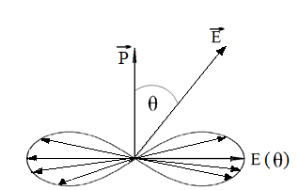

 Types of antennas

Antennas, in which the transverse dimensions (*d*) are small compared to the longitudinal ones (*L*), are called linear. G, T shaped for different polarizations of waves, loop for wavelengths λ ~ 2 L are used. For short waves (high frequencies), antennas, slot, strip, aperture, etc. are used.

The Hertz vibrator is a half-wave resonant antenna, consists of two parts with a length of λ / 4, a source is connected to the middle:

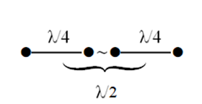

The distribution of current *I* , voltage *U*, complex resistance *Z* has an analogy with the characteristics of a pendulum: speed υ~I, potential energy $Е_{п}{\sim U}_{ }$, impedance Z=U/I (figure below).

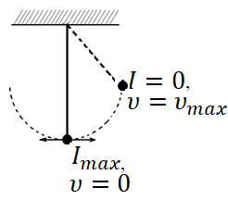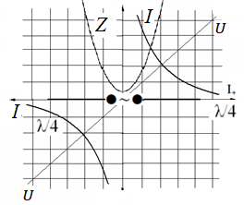

Grounded antenna (Marconi antenna)

One part λ/4 Hertz vibrator is buried in the ground. The wave is well reflected from clay (worse from sand). The result is the same as that of the Hertz vibrator. The gain is a reduction in the outer length of the antenna.

 Antenna array of transverse radiation to the plane of the antenna.

Antennas are connected through distances λ / 2 (half the wavelength) crosswise:

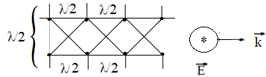

- - wave propagation vector

⊛ $\vec{E}$ is the perpendicular electric field vector.

Waves are formed with a phase shift of $π \left({180}^{о}\right)$ at the points λ/2. The result is N times amplification of $\vec{E}$ through N connections. Cases $N\sim {10}^{3}$ are used to amplify received space signals.

Longitudinal radiation grating along the antenna connection lines:

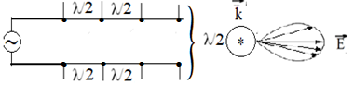

The electric field strength $\vec{E}$ is added along the antenna connection lines. The wavenumber vector $\vec{k}$ is perpendicular to $\vec{E}$.

There are many types of antennas, they contain combinations of these options. For example, the Yagi-Uda antenna combines the Hertz vibrator and the reflective element of the Marconi antenna.

 Characteristics of antennas used in practice.

Length x of the near (‘dead’) zone, where there is no radiation $\frac{x}{L}≲\frac{L}{λ} , x≲\frac{L^{2}}{λ}$, L is the length of the antenna, λ is the wavelength.

Antenna “gain” − $∆θ$ *= $\frac{λ}{L}$, $∆θ-$* interval of the polar angle limiting the radiation pattern. The antenna does not amplify the wave, ∆θ only characterizes the narrow directionality of the wave propagation.

Wave impedance $R=\frac{P}{I^{2}}$, *P-*is the power of the expended energy, I is the required current.